Adidas Sales Analysis SQL Queries

1. **Total Sales in the year of 2020:**

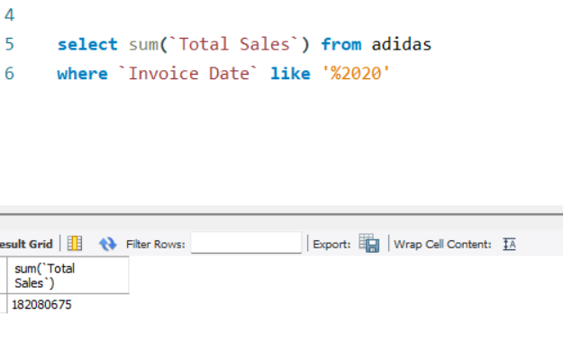

1. **Total Sales in the year of 2021:**

**3. Total Unit sold in the year of 2020:**

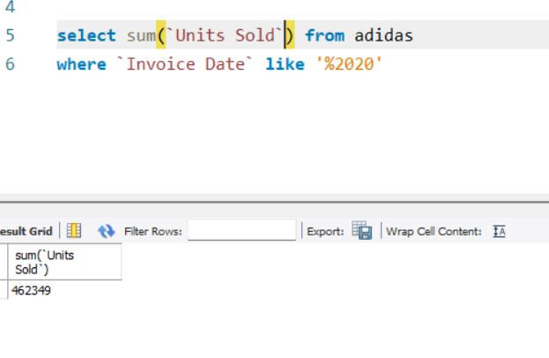**4. Total Unit sold in the year of 2021:**

**5. Top performing sales method:**

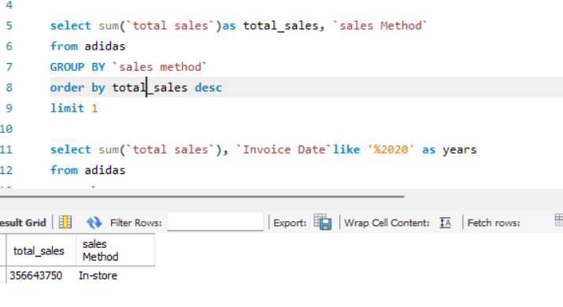

**6. Top performing region by total sales:**

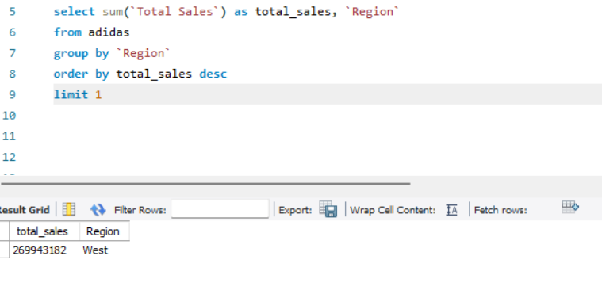

**7.Top performing region in the year of 2020:**

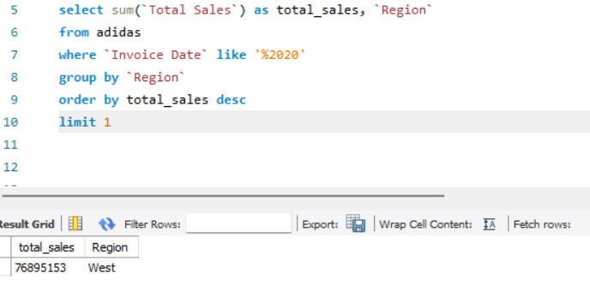

**8.Top performing region in the year of 2021:**

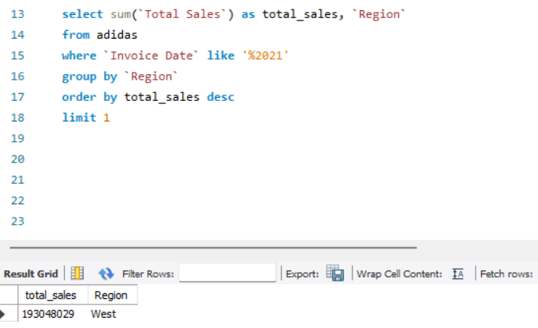

9.Top selling product in the year of 2020:

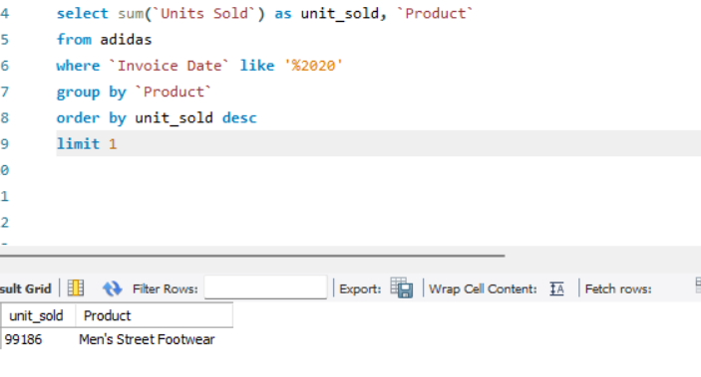

10.Top selling product in the year of 2021:

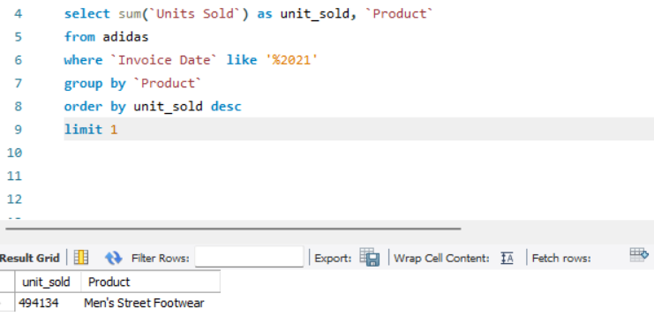

11. Top selling product in region wise:

